HANA

HANA ABAP – High Performance Analytical Tool

HANA DB + HANA studio HANA DB = HDB

HDB + BW on HANA

HDB + ECC

HDB + S/4 HANA

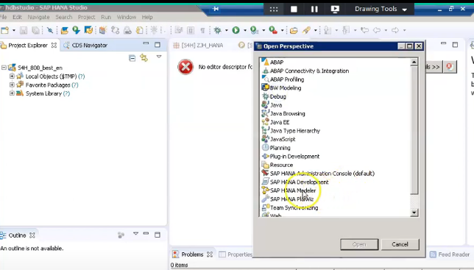

Modeler Perspective

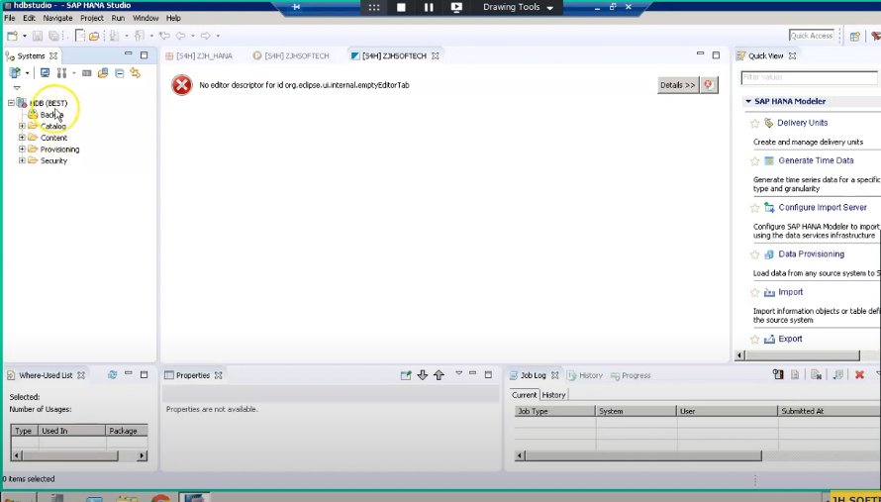

Catalog -> Schemas -> table

Schemas based tables = HANA based DB tables

In schemas

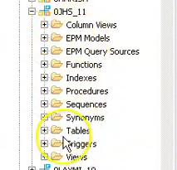

Content -> Package -> Views

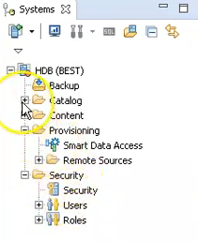

Create a Schemas

ABAP Perspective

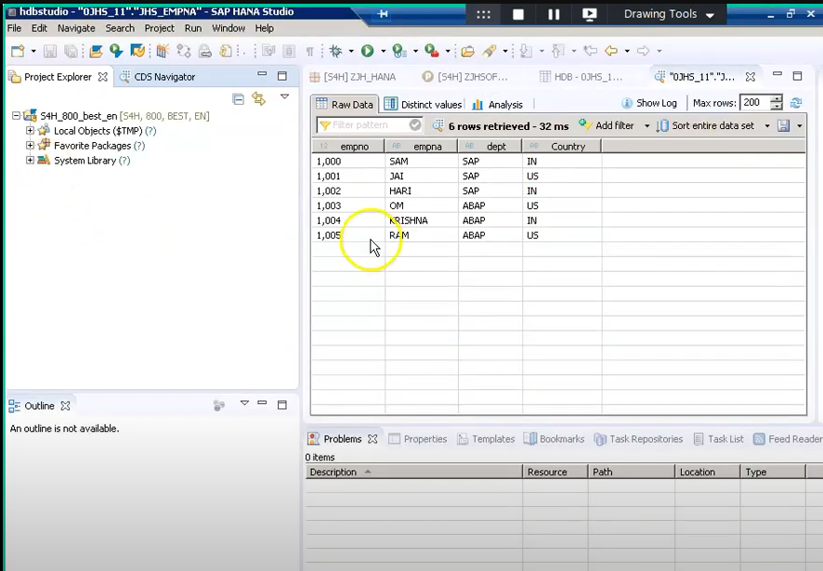

Create a package

